

# CAPSTONE PROJECT REPORT

# Report 1 – Small Grocery Store Stockroom Management Website

– Hanoi, September 2023 –

**Table of Contents**

I. Record of Changes 3

II. Project Introduction 4

1. Overview 4

1.1 Project Information 4

1.2 Project Team 4

2. Product Background 4

3. Existing Systems 5

3.1 Sapo Pos System 5

3.2 KiotViet System 5

4. Business Opportunity 6

5. Software Product Vision 7

6. Project Scope & Limitations 7

6.1 Major Features 7

6.2 Limitations & Exclusions 8

# 

# 

# I. Record of Changes

| **Date** | **A* M, D** | **In charge** | **Change Description** |
| --- | --- | --- | --- |
| 6/09/2023 | A | Luu Đuc Anh | Write Create Project Scope & Limitation |
| 8/09/2023 | A | Tran Tien Dat | Write software product vision |
| 9/09/2023 | A | Nguyen Anh Khoa | Write business opportunity |
| 11/09/2023 | A | Tran Hai Nam | Write Existing Systems |
| 11/09/2023 | A | Chu Van Luan | Write product background |
| 13/09/2023 | M | Luu Đuc Anh | Write Create Project Scope & Limitation |
| 13/09/2023 | M | Tran Tien Dat | Write software product vision |
| 14/09/2023 | M | Nguyen Anh Khoa | Write business opportunity |
| 14/09/2023 | M | Tran Hai Nam | Write Existing Systems |
|  |  |  |  |
|  |  |  |  |
|  |  |  |  |
|  |  |  |  |

*A - Added M - Modified D - Deleted

# II. Project Introduction

## 1. Overview

#### 1.1 Project Information

* Project name: Small Grocery Store Stockroom Management Website
* Project code: SGSSMS
* Group name: SEP490-G85
* Software type: Web Application

#### 1.2 Project Team

| **Full Name** | **Role** | **Email** | **Mobile** |
| --- | --- | --- | --- |
| Vuong Minh Tuan | Lecturer | tuanvm2@fe.edu.vn |  |
| Luu Duc Anh | Leader | anhhe151099@fpt.edu.vn | 0869678427 |
| Chu Van Luan | Member | luancvhe151322@fpt.edu.vn | 0981716630 |
| Tran Hai Nam | Member | namthhe151325@fpt.edu.vn |  |
| Tran Tien Dat | Member | dattthe151163@fpt.edu.vn | 0903496057 |

## 2. Product Background

Small Grocery Store Warehouse Management Website is a web application developed to manage various grocery products such as food, beverages, daily necessities stored in the warehouse.

Because our family-owned grocery store encountered issues related to product management such as tracking the expiration date of each item and locating products in the store. In addition to the above issue, We also support users for supplier reviews, recording and notification of unpaid invoices. So we started developing this system to solve the above problems.

The intended users of this project are grocery store owners. The project will be developed in C# programming language, using SQL Server as the database. Bootstrap 4 and JS used to create the user interface. The project is expected to have a three-month development period, including product development, testing and deployment phases.

## 3. Existing Systems

#### 3.1 Sapo POS System

Description: Sapo POS is a point-of-sale management software developed by Sapo Technology Joint Stock Company, a leading player in the multi-channel management and sales platform field. Sapo POS has one of the largest market shares in its category today. The software is designed to assist business owners in managing inventory, products, sales, employees, and analyzing business activities through accurate and specific reports both at the physical store and on their Fanpage.

Link: <https://www.sapo.vn/phan-mem-quan-ly-cua-hang-tap-hoa.html>

**System Actors:**

* Store Staff: Store staff are the primary users of the Sapo POS system. They use the system to manage inventory, conduct sales transactions, and process payments from customers.
* Customers: Customers are individuals who visit the store to make purchases. They interact with Sapo POS when making payments and receiving purchase receipts.
* Store Administrators: Store administrators have higher-level privileges compared to store staff. They can perform store management activities such as creating employee accounts, accessing reports, and managing store settings.
* Suppliers: Suppliers provide products to the grocery store, and they use Sapo POS to track orders, update product information, and manage deliveries.
* Electronic Payment Systems: Sapo POS can interact with various electronic payment systems to process payments from customers through online payment methods.
* System Administrators (Admin): System administrators have the role of managing system settings, security, and general configurations of the Sapo POS platform.
* Features:Inventory Management, Customer Management, Employee Management, Debt Management

**Pros:**

* Accessible to Everyone
* Double Sales Speed
* Prevent Errors and Loss of Goods
* Cons:
* Mismatched Inventory Between Sapo and the Shop
* Complex Warehouse Setup When Using the Mobile App:
* Not All Order and Customer Information Is Synchronized

#### 3.2 KiotViet System

Description: KiotViet is a product developed by Citigo Software Joint Stock Company, specializing in software development for customers in the Australian, French, and American markets. They collaborate with various experts in the retail industry.

The primary purpose of the KiotViet point-of-sale software is to serve retail stores in Vietnam. Its aim is to simplify and streamline the sales management process for businesses without incurring excessive costs, facilitating easy and efficient retail operations.

Link: <https://www.kiotviet.vn/>

**System Actors:**

* Store Manager: The person responsible for the grocery store with full access to the system.
* Sales Employees: They may have restricted access depending on their roles.
* Customers: The individuals shopping at the store.

**Features:**

* Product Management: Enables users to input and edit product information, monitor prices, and manage inventory.
* Inventory Management: Monitors inventory levels, creates purchase orders from suppliers, and manages the process of receiving and stocking goods.
* Employee Management: Assigns access rights to employees, tracks work hours, and manages payroll.
* Debt Management: Records customer payment transactions, tracks debts and payments received, and provides reports on customer debt status.

**Pros:**

* Optimized for medium and small businesses.
* Integrates numerous essential management features.
* Supports debt management to track customer financial status.

**Cons:**

* May require an initial investment for customization and implementation.

## 4. Business Opportunity

To solve the arising problems of a small grocery, the restaurant owners requested a QR code ordering system on the table to minimize the risks in the business. Specifically, our system brings a lot of benefits to customers

Necessity

* Grocery stores must monitor and approve daily inventory, track customer debt, and manage sales transactions. This can be time consuming and risks errors if done manually.

The project provides automation solutions to help store:

* Save time and resources.
* Minimize errors and inventory loss.
* Improve debt management and optimize the revenue and expenditure process.

## 5. Software Product Vision

For small grocery stores, the grocery warehouse management system is a web application, providing digital solutions to small grocery stores.

Small grocery stores that use our products:

1. Improve accuracy and performance and greatly reduce time in import and export items.
2. Manage debt information between customers and stores, store and suppliers.
3. Easily identify bad suppliers.

## 6. Project Scope & Limitations

### 6.1 Major Features

| **#** | **Feature** | **Description** |
| --- | --- | --- |
| FE-01 | Authentication | Use this feature to signup, login,logout, forget password, change password on the website. |
| FE-02 | Related Customer Invoice Information | Admin manager history debt, debt management, |
| FE-03 | Manager payment customer | Control which customers have paid their invoices, what money is owed, and the total amount a customer owes |
| FE-04 | Invoice with Supplier | Manage invoices for each product supplier, allow debt to product supplier, total amount owed |
| FE-05 | Manager Invoice | Manager take responsibility to CRUD the invoice of the system |
| FE-06 | Inventory Management | The Manager will perform CRUD operation on products in the warehouse |
| FE-07 | Manager product | Manager take responsibility to CRUD the product of the system |
| FE-08 | Product Management | Manager take responsibility information of product of the system |

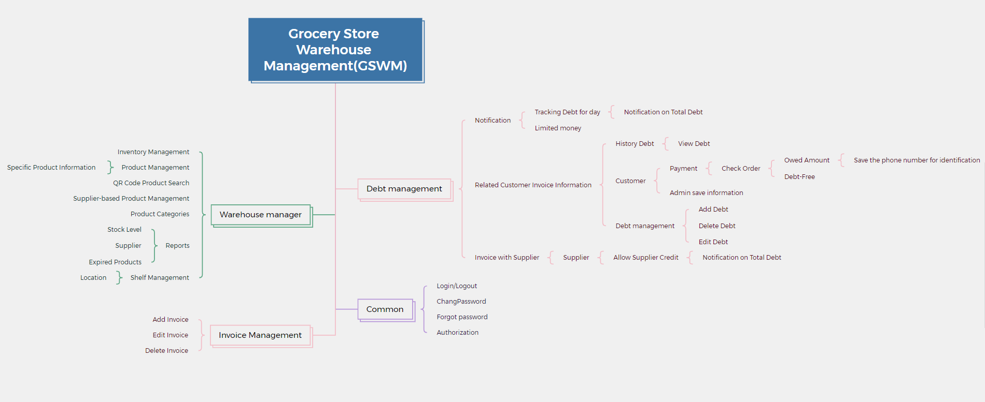

### 

### 

### 6.2 Limitations & Exclusions

Ll-1: Support for multiple stores

LI-2: A part of customers have limited technology, do not know how to use the system or do not use

smartphones.